BTree

# B树的B是什么意思

**Rudolf Bayer and Ed McCreight invented the B-tree** while working at **Boeing Research Labs** in 1971 (Bayer & McCreight 1972), but they did not explain what, if anything, the B stands for. Douglas Comer explains:

The origin of "B-tree" has never been explained by the authors. As we shall see, "balanced," "broad," or "bushy" might apply. Others suggest that the "B" stands for Boeing. Because of his contributions, however, it seems appropriate to think of B-trees as "Bayer"-trees. (Comer 1979, p. 123 footnote 1)

Donald Knuth speculates on the etymology of B-trees in his May, 1980 lecture on the topic "CS144C classroom lecture about disk storage and B-trees", suggesting the "B" may have originated from Boeing or from Bayer's name.[2]

Ed McCreight answered a question on B-tree's name in 2013:

Bayer and I were in a lunchtime where we get to think [of] a name. And ... B is, you know ... We were working for Boeing at the time, we couldn't use the name without talking to lawyers.

So, there is a B.

[The B-tree] has to do with balance, another B.

Bayer was the senior author, who [was] several years older than I am and had many more publications than I did. So there is another B. And so, at the lunch table we never did resolve whether there was one of those that made more sense than the rest. What really lives to say is: the more you think about what the B in B-trees means, the better you understand B-trees."[3]

<https://blog.csdn.net/stpeace/article/details/78070814>

# M阶的BTree的几个重要特性

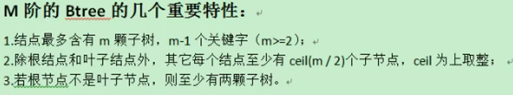

根据内存页计算：M。

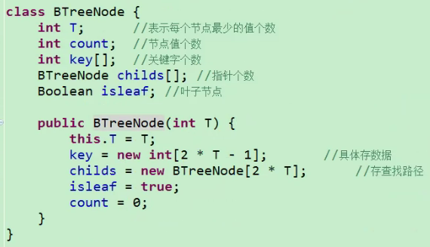

# B树的插入操作

树的深度：树的深度决定了查找的次数。

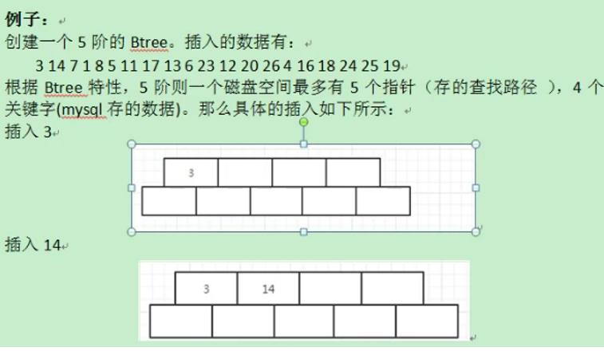

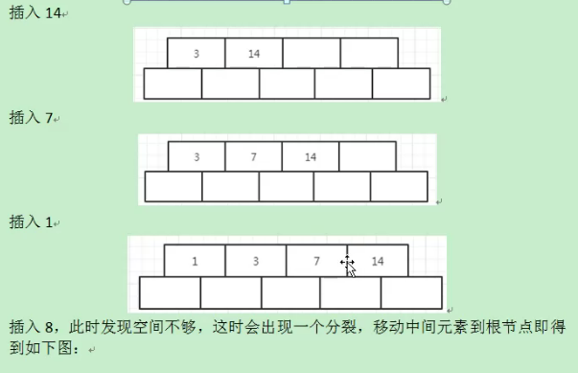

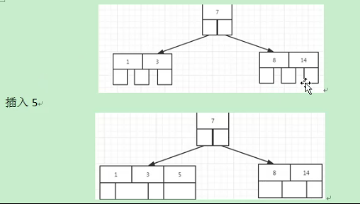

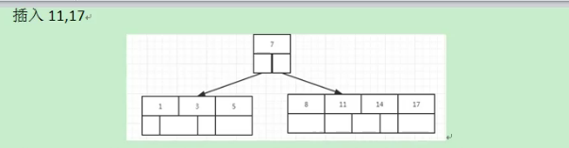

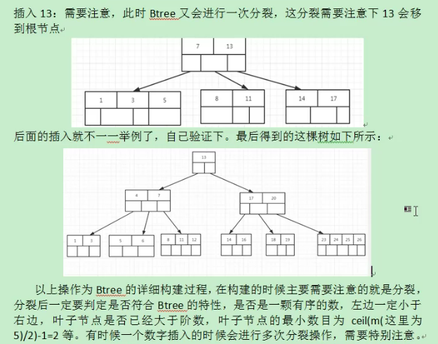

分裂：

# B+Tree和BTree的区别：

